Newsletter

September 2013

Welcome Back Students

The teachers, administration, secretaries, food service staff and custodial staff would like to say, “Welcome” to the 2013-14 school year. The mission statement of Lawton Middle School states: “all students will learn the academic and social skills necessary to be successful in school and in life” and we strive to achieve this mission. Academically, we have high expectations for all of our students with a curriculum that is aligned with the Common Core State Standards. Our focus is to prepare our students to be College Ready by the time they graduate high school. The Character Building program at school as well as student mentoring assists in the social development of our young adolescents.

**Attendance at School**

One of the biggest factors for student success at school is their regular attendance at school. Children need to know that attending class each day is a vital part of their education as well as a lifelong skill as they enter the work force. As parents, we can help implant this concept in the minds of our children through some basic expectations. Consider scheduling dental appointments and other appointments after school hours. Promote the completion of homework each night avoiding the last minutes project hassle. Maintain information on the number of days your child has been absent from school and keep your child “in the know” of the school’s attendance policy. Excessive absences may result in consequences up to and including detentions, suspensions and truancy documentation and involvement. The middle school years are challenging as is, therefore, attending school daily is important for their success.

**School Safety**

State law requires schools to practice fire drills, lock-down drills and tornado drills throughout the school year. Each drill is taught and practice with our students. The middle school has completed one fire

drill and one lock-down drill during the first week of school. Also, all doors will remain locked with a buzzer system and camera system used at the front doors to allow visitors into the building. Student safety is of high priority.

Cyber bullying

Cyber bullying occurs when someone sends hurtful messages online or by cell phone and other electronic devices. It can take many forms, such as writing rude comments, spreading rumors and posting embarrassing pictures. Your child can discourage cyber bulling by giving personal information (name, email address, cell phone number) only to friends. If she receives nasty emails or text messages, she should not respond. Explain that replying just gives the person the satisfaction of having upset her. A good thing to do is imply to log off the computer or turn off the cell phone.

Let your youngster know she should tell an adult if she experiences cyber bullying. You can report problems to your Internet provider and if threats of harm are made, contact the police for assistance. (Taken from the Middle Years a resource for educators)

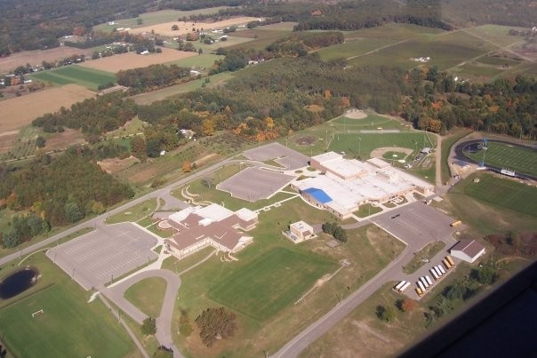

**Parent Volunteers Welcome**

The middle school is looking for parent volunteers who are willing to assist in the classroom, even for only a few hours. Please call the office at 624-7610 and Mrs. Willis will gather the information.

*Byline Company* - Use this style to type the author’s company.

Sidebar Head - Use this style to type a second-level heading i a sidebar article.

Sidebar Subhead - Use this style to type a third-level heading in a sidebar article.

Sidebar Text - Use this style to type the text in a sidebar article.

Sidebar Title - Use this style to type first-level headings in a sidebar article.

Footer - Use this style to type the repeating text at the very bottom of each page.

Heading1 - Use this style to create headlines for each article.

Heading2 - Use this style to create section headings in an article.

Jump To and Jump From - Use these styles to indicate that an article continues on another page.

Mailing Address - Use this style in a mailing label to type the destination address.

Postage - Use this style in a mailing label to type postage information.

Return Address - Use this style in a mailing label to type your address.

Picture Caption - Use this style to type a description of a picture or illustration.

Subtitle - Use this style to type sub-headings in an article.

Use PullQuote to excerpt text from the main text of a story to draw a reader’s attention to the page. See page 4 for an example.

